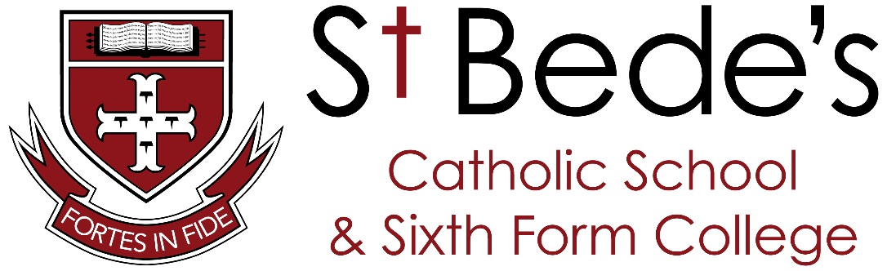

CEIAG Policy

2025 - 2026
Governing Body Approval: Full Governing Body
Name: | Signature:
Date | For application 25/26
Adopted revision | Next revision Autumn Term 2027

Policy for Careers
Education, Information, Advice and Guidance
Including Provider Access Arrangements
St Bede’s Catholic School and Sixth Form College, Lanchester
2025/26

The School Mission Statement
At St. Bede’s Catholic School and Sixth Form College, our mission is rooted in our motto:
Fortes in Fide – Strong in Faith.

We are committed to creating an atmosphere filled with Catholic values, attitudes, practice, and knowledge—where every child has the opportunity for their faith to be nurtured. Our goal is that all students grow in faith and character, so they may deepen and widen themselves as people, fully prepared for the challenges of this life and the life to come.

We draw inspiration from the words of 1 Peter 5:8–9:
“Be sober, be vigilant; because your adversary the devil walks about like a roaring lion, seeking whom he may devour. Resist him, steadfast in the faith, knowing that the same sufferings are experienced by your brotherhood in the world.”

Our mission is brought to life each day through the St. Bede’s School Values, which guide our community:

· Strength in Faith – Living with trust in God and growing spiritually.
· Together as a Family – Building a welcoming, caring, and respectful school community.
· Be the Best Version of Yourself – Supporting every student to realise their full God-given potential.
· Excellence in All That We Do – Striving for high standards in learning, character, and service.
· Discipleship – Serving Others as Christ Did – Encouraging a life of compassion, leadership, and selflessness.
· Environment – Caring for Our Planet – Embracing stewardship and responsibility for God’s creation.

At St. Bede’s, we aim not only to educate minds, but to shape hearts. We help students become confident, compassionate, and faith-filled individuals who live with purpose and serve with joy.

This policy statement sets out the school’s arrangements for managing the access of providers to the school for the purpose of giving them information about the provider’s education or training offer. This complies with the school’s legal obligations under Section 42B of the Education Act 1997.

North Durham Demographic
St Bede’s Catholic School and Sixth Form College is situated in the small rural village of Lanchester. The catchment area not only covers this area but also the towns of Consett and Stanley and their environs. This area falls into the North Durham area of the County.

County Durham shares many of the problems of the North of England, arising from a long-term pattern of sectoral change and industrial decline. It also has unique challenges arising from its legacy of scattered industrial settlements, and its lack of a large urban area to drive growth.

The school’s catchment area falls into three areas each with very distinct character and differing social/ cultural / economic settings.

- Consett /Derwent Valley
- Lanchester
- Stanley
The Stanley and Derwent Valley areas are predominantly ‘urban’ in nature with a joint population in the region of 79,800 . The majority of settlements in this area are former pit villages, a legacy of the significant mining undertaken in the area up until the 1980s. Consett was also dominated by a steel works until this time too. Interspersed between the settlements are areas of rough moorland and fells, a reminder that the land which covered the coal was mainly agricultural. The village of Lanchester, where the school is has a more agricultural/dormer town presence in the community.

Deprivation
The most prevalent forms of deprivation in County Durham are related to Income, Employment, and Health, with lower levels in education, crime, and living environment compared to other indices.
Deprivation in North Durham is characterised by significant poverty rates, with County Durham having a higher percentage of children in relative poverty than the national average. Many areas within the county are ranked among England's most deprived, which face challenges related to income, employment, and the overall living environment. These areas exhibit high numbers of people experiencing poverty and unemployment, but there are also specific communities experiencing better outcomes.

Qualifications
Durham Insight shows that in 2021, 20.7% of the population had no qualifications, 43.7% had Level 1-3 qualifications, 26.3% had Level 4+, and 6.8% had apprenticeships.
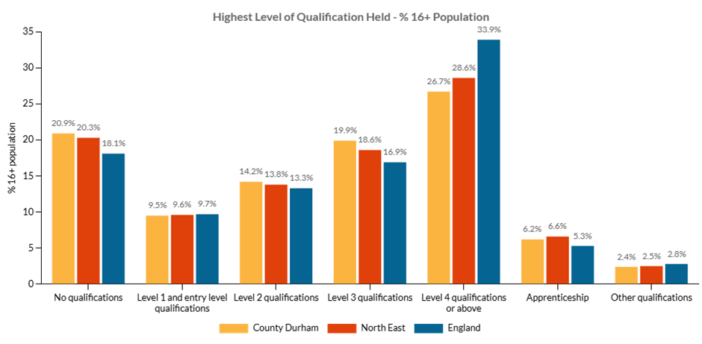

Worklessness
Worklessness in County Durham is characterised by an economic inactivity rate of 8.9%, but this figure is higher than the UK average.

While unemployment rates are relatively low, the main driver of worklessness is economic inactivity, primarily due to long-term sickness and early retirement.

Key Statistics
Workless Rate: 8.9% of people aged 16-64 in County Durham are workless (defined as unemployed plus economically inactive but wanting a job).

Unemployment Rate: The unemployment rate in County Durham is around 3.6% to 3.8%, which is lower than the national average.

Economic Inactivity: The primary reason for worklessness is economic inactivity, with a rate of 8.9% in County Durham, exceeding the national average.

Factors Contributing to Worklessness
Economic Inactivity: A significant portion of the working-age population is not in the labor force but also does not want a job.

Long-Term Sickness: A key contributor to the rise in economic inactivity is long-term sickness, a regional and national trend.

Early Retirement: Another factor in the increase in economic inactivity is early retirement.

Youth Unemployment: While overall unemployment is low, unemployment among young people (18-24) has been a challenge, although rates have fallen from recent highs.

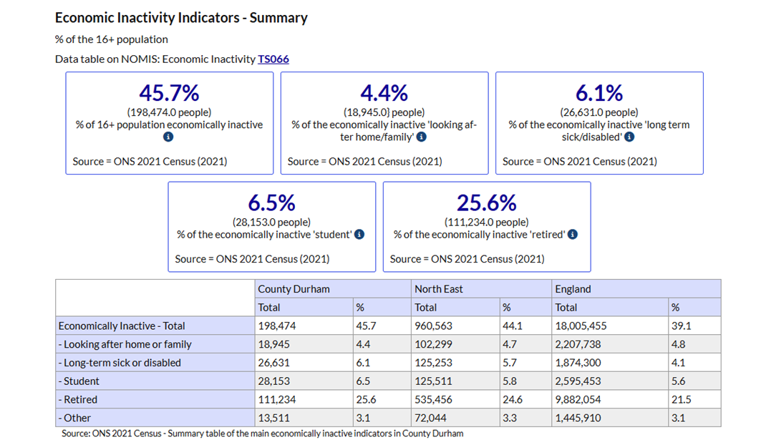

Rationale for CEIAG in St Bede’s

Statutory Guidance informs us that High-quality careers guidance helps young people:
- make informed choices about their futures, so they can develop their interests and potential, and follow the path that is right for them to progress into work
- break down barriers to opportunity
- improve skills needed for success in work
- improve national productivity and grow the economy
High-quality careers provision is an essential part of the government’s missions to break down barriers to opportunity and to drive economic growth. Economic growth relies on individuals having the skills, ambitions and opportunities they need to succeed in fulfilling careers, so that we can meet skills gaps in priority sectors and improve national productivity.Careers choices start at school. Every young person, regardless of their background, must be able to achieve at school to develop the knowledge and skills they need for life. This can be achieved by:
- improving school standards with excellent teachers and leaders who develop and adopt best practice
- improving attendance, health and wellbeing in and out of school
- addressing inequality and adopting an inclusive approach to special educational needs and disabilities (SEND)
- ensuring access to a broad curriculum with wider enrichment opportunities

Careers guidance and access for education and training providers-Updated 8 May 2025
With the issues above in mind, St Bede’s CEIAG Self Evaluation and Improvement Plan and CEIAG Plan sets
out to sustain links with employers and outside agencies in order to inspire young people to consider a broad range of careers which promote the best interests of the young person and encourages positive destinations for every young person leaving St Bede’s.

This is to contribute to the raising the educational achievement of County Durham’s young people and to help them to make informed career choices linked to the needs of the local, national and global economy.

A young person’s career reflects the progress they make in learning and work. It is part of the vision and mission of St Bede’s Catholic School that all learners need a planned programme of activities to help them choose 14-19 pathways that are right for them and to be able to manage their careers, sustain employment and achieve personal and economic wellbeing throughout their lives.

Commitment

St Bede’s Catholic school references the following legislation in its CEIAG activity

- Section 42A, 42B, 45 and 45A of the Education Act 1997
- Section 72 of the Education and Skills Act 2008
- Schedule 4 (15) of the School Information (England) Regulations 2008
- Education (Careers Guidance in Schools) Act 2022
- The Skills and Post-16 Act 2022
- Careers guidance and access for education and training providers-Updated 8 May 2025

St Bede’s Catholic School recognises that it has a responsibility to ensure all registered pupils at the school are provided with independent careers guidance from year 7 (11-13 year olds) to year 13 (17-18 year olds), (Education Act 1997, section 42A). The governing body also recognises that it must ensure that the independent careers guidance provided:

- is presented in an impartial manner
- includes information on the range of education or training options, including apprenticeships and other vocational pathways
- is guidance that the person giving it considers will promote the best interests of the students to whom it is given.

St Bede’s Context  St Bede’s is part of BISHOP WILKINSON CATHOLIC EDUCATION TRUST which contains 31 primary schools,  6 secondary schools, no special schools, and no pupil referral units.  We are a lead school in the School Direct Partnership (ITT) through our close partnership with Durham SCITT | St Bede’s Pupil Population-25/26
 | Total number on roll | 1254
 | Girls on roll | 640
 | Boys on roll | 614
 | Pupils with SEND/EHC Plans | 224
 | Pupils with SEND Support | 200
 | Pupils first language not English | 92
 | Pupils eligible for Free School Meals during past 6 Years | 273

Post 16 Data

Most of the measures published here, in April 2025, relate to students who completed key stage 4 in the summer of 2024, with the exception of destination measures, where the cohorts reported are stated below.

Pupils included in this performance data will have experienced some disruption due to Covid-19 earlier in their schooling, which will have affected individual pupils and schools differently.
Read More

April 2025 – most up to date data
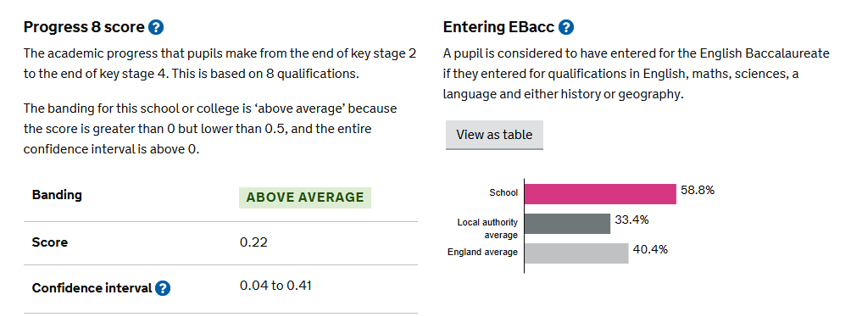

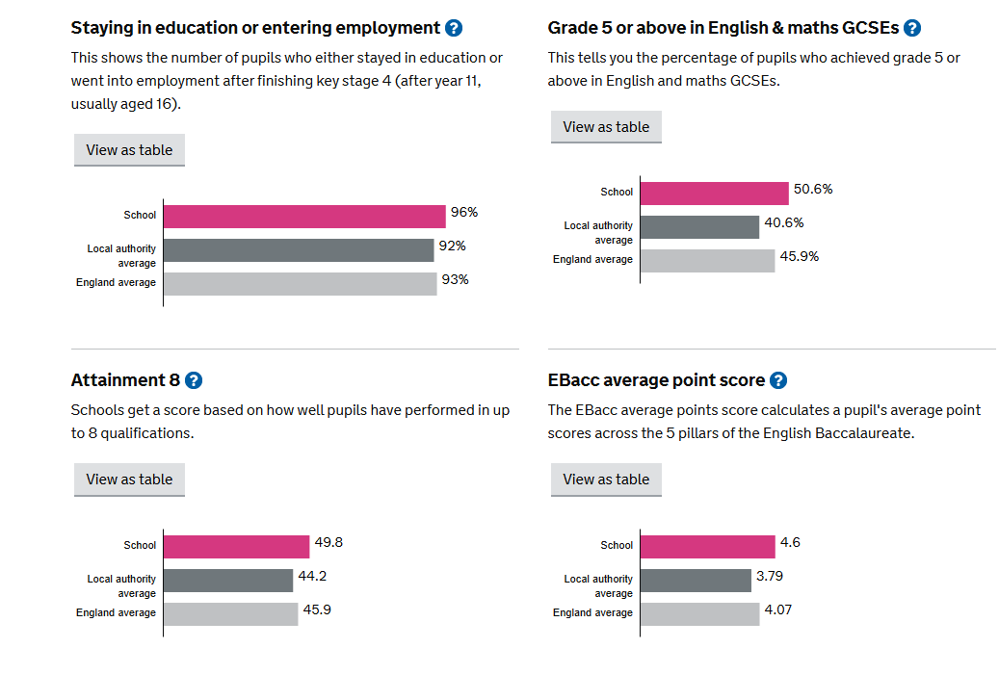

Pupil destinations (2022 leavers)
This data is for pupils who completed key stage 4opens a popup in 2022, which is the most recent data available

Post 18 Data

Student destinations after 16 to 18 (2022 leavers)

Students reaching the end of 16 to 18 study in 2022 and staying in education or employment for at least 2 terms after this. This is revised data published in February 2025. Students that left 16 to 18 study at this school or college in 2022, who either stayed in education or went into employment from October to March the following year, or stayed in an apprenticeship for at least 6 months.
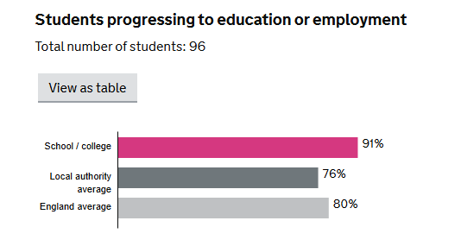

Key Stage 5 Data

Managing the access of providers
This policy statement also sets out the school’s arrangements for managing the access of providers to pupils at the school for the purpose of giving them information about the provider’s education or training offer. This complies with the school’s legal obligations under Section 42B of the Education Act 1997,

The school endeavours to follow best practice guidance from the Department for Education and other expert bodies such as Ofsted and professional bodies related to CEIAG including published research as it is available.

The government strongly recommends that all schools and colleges work towards the national Quality in Careers Standard to support the development of their careers programme. This external assessment allows independent judgement of the quality of careers provision, including its impact upon learners’ career-related learning.
St Bede’s Catholic School has achieved the Quality in Careers Standard and will have an external review every year and will seek to renew the award in July 2027.


Development
This policy was developed and is reviewed annually in discussion with school leaders, teaching and teaching support staff, learners, parents, governors, advisory staff and other external partners (e.g. the Local Authority, National Careers Service, National Apprenticeship Service, Local Enterprise Partnership).
Links with other policies
The policy for CEIAG supports and is itself underpinned by a range of key school policies especially those for teaching and learning, assessment, recording and reporting achievement, special educational needs and disability, equality and diversity, gifted and talented, looked after children and PSHE.

OBJECTIVES
Learners’ needs
The careers programme is designed to meet the needs of learners at St Bede’s Catholic School. Activities are differentiated and personalised to ensure progression in their career learning and development, and to strengthen their motivation, aspirations and attainment at school.
Pupil Entitlement
Learners are entitled to impartial and confidential CEIAG which is person-centred, delivered by trained staff and which meets professional standards of practice. Activities will be integrated into the curriculum and based on a partnership with learners and their parents/carers. The programme will raise aspirations, challenge stereotyping and promote equality and diversity.

All pupils in years 7 to 13 are entitled:
• to find out about technical education qualifications and apprenticeships opportunities, as part of a careers programme which provides information on the full range of education and training options available at each transition point.
• to hear from a range of local providers about the opportunities they offer, including technical education and apprenticeships – through options events, assemblies and group discussions and taster events;
• to understand how to make applications for the full range of academic and technical courses.

For pupils of compulsory school age these encounters are mandatory and there will be a minimum of two encounters for pupils during the ‘first key phase’ (year 8 to 9) and two encounters for pupils during the ‘second key phase’ (year 10 to 11). For pupils in the ‘third key phase’ (year 12 to 13), particularly those that have not yet decided on their next steps, there are two more provider encounters available during this period, which are optional for pupils to attend.

These provider encounters will be scheduled during the main school hours and the provider will be given a reasonable amount of time to, as a minimum:
• share information about both the provider and the approved technical education qualification and apprenticeships that the provider offers
• explain what career routes those options could lead to
• provide insights into what it might be like to learn or train with that provider (including the opportunity to meet staff and pupils from the provider)
Meaningful provider encounters
A Meaningful encounter is defined as one meeting/session between pupils and one provider. We are committed to providing meaningful encounters to all pupils using the Gatsby Benchmarks
Meaningful online engagement is also an option, and we are open to providers that are able to provide live online engagement with our pupils.

A meaningful encounter gives the young person the opportunity to explore what it is like to learn, develop and succeed in that environment. This should include the opportunity to meet both staff and learners/trainees. Throughout a careers programme, encounters should be sequenced so that a young person can build up a clear picture of opportunities available to them. Experiences or encounters could be in person or a combination of in person and virtual and could include providers delivering sessions in a school, college or ITP, as well as young people visiting the provider. Young people and providers should be supported to prepare for the encounter. Additional or different support may be needed for vulnerable and disadvantaged young people and for young people with special educational needs and disabilities (SEND)- Gatsby Benchmark 7

IMPLEMENTATION
Management
The Career Progression Manager, Mrs A Jukes will manage the careers education programme and is responsible to the Deputy Head Teacher /Ethos & Personal Development Lead. CEIAG is supported by a link Governor: Mr D. Dixon and Enterprise Advisors linked to the North East Combined Authority Careers Hub Work experience is planned and implemented by the school which works closely Unifrog to manage the placements through their on-line system. We also encouraged students to undertake virtual experiences and volunteering to support this area of their development.
If you would like to get in contact with Mrs Jukes - Careers Lead, please e-mail stbedes@stb.bwcet.com
Staffing
All staff will contribute to CEIAG through their roles as tutors and curriculum subject teachers. Specialist sessions are delivered by a range of staff including the Career Progression Manager, form tutors and ‘external professionals’, co-ordinated by the Career Progression Manager. The CEIAG programme is planned, monitored and evaluated by the Career Progression Manager in consultation with the senior leadership team. Careers information is available in a variety of formats, printed within the Sixth Form /career interview area & electronic within the school website and network. These resources are maintained by the Career Progression Manager with support from the ICT support staff.

Curriculum
St Bede’s prides itself in preparing students for the next stage of their life, not only academically but in relation to future career pathways. Where ‘career’ was once thought of as a single commitment to a lifelong occupational pursuit, it is now thought of as a lifelong journey whereby individuals participate in differing learning and work roles. At St Bede’s we hope to contribute to and prepare young people for that journey.
We have relevant Careers Education Modules built into our PHSE programme from Year 7 through to 6th Form which draw upon many visiting speakers from local organisations, FE Colleges, and Universities.
Within our programme students:

• Learn about the structures, systems and factors that guide, shape and influence people’s career prospects and career development
• Explore how these could affect their future choices, why they need to consider them when making their own career decisions and plans, and how they can do so
• Develop and practice the self-help skills they need to progress their own career plans and development, including the effective use of IAG (Information, Advice & Guidance)

Our Careers Programme includes.
Careers Education- Careers lessons are part of the school’s Personal Development Program. Sections of work for careers are planned into the personal development calendar throughout the year.
Careers Information – students have access to accurate, up-to-date and objective information on opportunities, progression routes, choices, where to find help and advice and how to access it. We work in partnership with local colleges and employers to ensure students have access to the best opportunities in the career market. We also use relevant Labour Market Intelligence data to help students make informed choices. We signpost parents/carers & students to a wide range of career platforms and websites to stimulate interest in a wide range of sectors.
Careers Advice – We have a range of activities that help young people to gather, understand and interpret information and apply it to their own situation. For example, we have a Careers Carousel events for every year group from Y7 to Y11 and a series of Careers Workshops throughout sixth form which allows students to discuss careers with industry ambassadors from a vast range of sectors, Colleges and Universities.
Careers Guidance – we provide impartial guidance and specialist support to help young people understand themselves and their needs, confront barriers, resolve conflicts, develop new perspectives and make progress.
All Year10/ 11 and 12/13 students have a one-to-one Progression Interview with our Career Progression Manager, Anne Jukes, to prepare them for post 16/18 choices. All other year groups can book appointments or drop-in during break or lunchtimes or free periods to access IAG.

Impact of CEIAG
Learners are involved in the planning of career learning. Their views are collected using student voice/surveys.
At St Bede’s we judge the impact of CEIAG through
• examining & evaluating what we do,
• thinking about how we can improve it,
• deciding on whether it was worth doing again in that particular format (we pilot many activities before extending to full scale),
• providing summaries to disseminate understanding of what was done to stakeholders such as parents/students/staff/governing body/visiting organisations involved with careers events.

All our CEIAG work is mapped against the CDI (Career Development Institute) Framework, Gatsby Benchmarks and the PSHE Framework

The main purpose of the CDI’s Career Development Framework is to clarify the skills, knowledge, and attitudes that individuals need to have a positive career. A ‘positive career’ will mean something different to everyone, but it will typically include being happy with the way you spend your time, being able to make a contribution to your community and being able to have a decent standard of living.
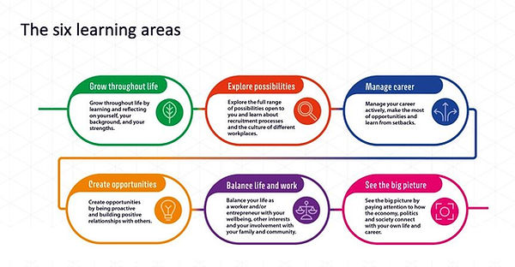
• Grow throughout life by learning and reflecting about yourself, your background, and your strengths
• Explore the full range of possibilities open to you
• Manage your career actively, making the most of opportunities, and learning from setbacks
• Create opportunities by being proactive and building positive relationships with others
• Balance life and work effectively
• See the big picture by paying attention to how the economy, politics and society connect with,
and affect your own life and career.

Gatsby Benchmarks
​
Good career guidance helps inspire students towards further study and enables them to make informed decisions whenever choices are open to them. It helps them to understand enough about the world of work to know what skills they need to succeed. It is important for social mobility because it helps open students’ eyes to careers, they may not have considered. With support from our the NECA Careers Hub and The Careers Company we have met our 8 Gatsby Benchmarks
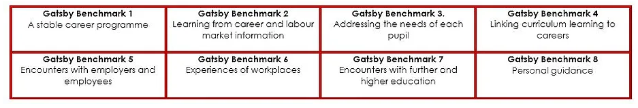

Overall CEIAG & Personal Development plans can be found on St Bede’s School website
https://stbedeslanchester.bwcet.com/

Careers Work within Personal Development develops the six capabilities for work & future career.

CHECKLIST for your future -The six capabilities for work
1.Self-aware | - Take responsibility for yourself and others  - Exhibit self-control  - Be accountable for your actions.  - Do not shift blame  - Recognise your own strengths and weakness | 
2.Receptive | - Be willing to address weaknesses  - Take feedback and advice  - Be open to new ideas and working in different ways  - Be open-minded, patient and flexible. | 
3.Driven | - Display a positive attitude  - Apply yourself consistently  - Be reliable, motivated, punctual, well-organised, hard-working  - Go the extra mile | 
4.Self-assured | - Have good levels of self-esteem  - Be willing to ask questions and seek more information  - Be prepared to work alone without clear direction  - Be prepared to work effectively within teams  - Display signs of self-esteem | 
5.Resilient | - Learn to cope with rejection and set-backs.  - Learn from mistakes  - Be open to constructive criticism,  - Be determined to overcome obstacles  - Persevere and do not panic under pressure | 
6.Informed | - Have an understanding of the jobs market.  - Display an ability to search for job vacancies and complete background research  - Understand office etiquette  - Be well-presented  - Be effective in describing your achievements verbally and have a representative CV | 
Work-readiness
- Make sure you are fully informed about the sectors you are interested in working in
- Familiarise yourself with the most up-to-date labour market information.
- Speak to a professional in the career area you want to be in –it may lead to work experience
- Talk to your family, friends, and neighbours they may have contacts.
- Even if experience is not directly relevant to the career path you wish to pursue, it can provide an opportunity to develop transferable skills described above.

Partnerships
We work very closely with Durham County’s Progression Team-Children and Young People’s Services to share data on Intended Destinations to allow DurhamWorks colleagues to support our young people and reduce students Not in Educations or Employment (NEET’s). Data sharing agreements are reviewed annually.
We also work in partnerships with our 5 local FE colleges and 5 Local universities as well as numerous training providers to ensure successful outcomes for our young people.
We have also longstanding links with The National Apprenticeship Service and Job Centre Plus
A list of our Work experience supports can be found in the Work experience Section of our website
https://stbedeslanchester.bwcet.com/students/careers/work-experience/

Destinations of our pupils
Last year our year 11 and year 13 pupils moved to range of local and national Post 16 & Post 18 providers

Resources
Funding is allocated in the annual budget planning round in the context of whole school priorities and particular needs in CEIAG. The Career Progression Manager is responsible for the effective deployment of resources.

Professional development
The Career Progression Manager has a Master’s in Education with specialisms in managing CEIAG and work-Related Learning in a Secondary setting and the statutory Level 6 Award in Careers Guidance which has an extended specialism in SEND to allow her to deliver Personal Guidance to students (Gatsby 8).
The Career Progression manager will attend all relevant CEIAG training opportunities and network meetings to update knowledge and skills and disseminate information relating to CEIAG throughout school by way of meetings, briefings, and staff training.

There are updates and training opportunities for all school staff. An assessment of whole school staff training needs is done annually or more frequently by request. Staff training needs relating to CEIAG are identified and school endeavours to meet training needs within a reasonable period of time.

Management of provider access requests

A provider wishing to request access should contact in the first instance Anne Jukes, Career Progression Manager
01207 520 424
ajukes@stb.bwcet.com

Safeguarding/ Visitors into school
Please refer to the following policies,
https://www.stbedes.durham.sch.uk/safeguarding

Opportunities for access
A number of events, integrated into the school careers programme, will offer providers an opportunity to come into school to speak to pupils and/or their parents/carers.
Many of our events have virtual alternatives that can be deployed should they be needed.
We will endeavour to incorporate live encounters and off-site visits into our programme if we can accommodate within the School Timetable /Subject areas or CEIAG programme.
Occasionally we may need to adapt or reschedule due to unforeseen circumstances
Below you will find a general outline of activities we offer in addition to subject specific encounters in departments and our PSHE sessions. We are also happy to discuss any opportunities that providers can offer to support our programme

Premises and facilities
The school will make the main hall, classrooms or private meeting rooms available for discussions between the provider and students, as appropriate to the activity. The school will also make available AV and other specialist equipment to support provider presentations. This will all be discussed and agreed in advance of the visit with the Career Progression Manager or a member of the wider student support teams
Providers are welcome to leave a copy of their prospectus or other relevant course literature at our reception for use within our careers library which is available to all students.

CEIAG Compliments and Complaints
Policy and Procedure

1. Our Aim
St Bede’s is committed to providing a quality CEIAG Programme and working in an open and accountable way that builds trust and respect with our partners One of the ways in which we can continue to improve our service is by listening and responding to the views of our Partners and visiting organisations, and in particular by responding positively to complaints, and by putting mistakes right.
Therefore, we aim to ensure that:
- making a compliment or complaint is as easy as possible
- we welcome compliments, feedback, and suggestions
- we treat a complaint as a clear expression of dissatisfaction with our school which calls for an immediate response
- we deal with it promptly, politely and, when appropriate, confidentially
- we respond in the right way - for example, with an explanation, or an apology where we have got things wrong, or information on any action taken etc.
- we learn from complaints, use them to improve our service, and review annually our CEIAG complaints policy and procedures
We recognise that many concerns will be raised informally and dealt with quickly.
Our aims are to:
- resolve informal concerns quickly
- keep matters low-key
- enable mediation between the complainant and the individual to whom the complaint has been referred
This policy ensures that we welcome compliments and provide guidelines for dealing with complaints from partner organisations about our events, facilities, staff, and students
2. Definitions
A compliment is an expression of satisfaction about the standard or organisation and execution of CEIAG Events and encounters
A complaint is defined as any expression of dissatisfaction; however, it is expressed. This would include complaints expressed face to face, via a phone call, in writing, via email or any other method. All staff should have sufficient knowledge to be able to identify an “expression of dissatisfaction” even when the word “complain”, or “complaint” is not used.
3. Purpose
We are always glad to hear from organisations and individuals who are satisfied with the organisation of CEIAG events we offer. All compliments are recorded, acknowledged, and a copy is sent to the relevant Senior Leader, Head of Year, or Form tutor to provide feedback to the member of staff or student

4. Complaints
The formal complaints procedure is intended to ensure that all complaints are handled fairly, consistently, and wherever possible resolved to the complainant's satisfaction.
5. Responsibilities
St Bede’s responsibility will be to:
- acknowledge the formal complaint in writing.
- respond within a stated period of time.
- deal reasonably and sensitively with the complaint; and
- take action where appropriate.

A complainant's responsibility is to:
- bring their complaint, in writing, to Anne Jukes- Career Progression Manager’s attention normally within 8 weeks of the issue arising.
- raise concerns promptly and directly with a member of staff at the CEIAG event
- explain the problem as clearly and as fully as possible, including any action taken to date;
- allow St Bede’s a reasonable time to deal with the matter, and
- recognise that some circumstances may be beyond St Bede’s ’s control.

6. Confidentiality:
Except in exceptional circumstances, every attempt will be made to ensure that both the complainant and St Bede’s maintain confidentiality. However, the circumstances giving rise to the complaint may be such that it may not be possible to maintain confidentiality (with each complaint judged on its own facts). Should this be the case, the situation will be explained to the complainant.

7. Complaints Procedure:
Written records must be made by St Bede’s at each stage of the procedure.
Stage 1
In the first instance, staff member(s) must establish the seriousness of the complaint. An informal approach is appropriate when it can be achieved. But if concerns cannot be satisfactorily resolved informally, then the formal complaints procedure should be followed.

Stage 2
If the complaint cannot be resolved informally, the external organisation should be advised that a formal complaint may be made, and the following procedure should be explained to them. It may sometimes be appropriate for a different member of staff, preferably a member of the Management Team, to make this explanation.
- A formal complaint can be made either verbally or in writing. If in writing the attached form should be used. If verbally, a statement should be taken by a member of the Management Team, or staff member
- In all cases, the complaint must be passed on to the Career Progression Manager– Anne Jukes. In the event of a complaint about The Careers Manager the complaint should be passed to the Senior Team if the complaint is about the Senior Team this must be passed on to Head Teacher or Chair of Governors
- Depending on the nature of the complaint, acknowledgement of the complaint will be in writing within two weeks of receiving it.
- One of the above will investigate the complaint. Any conclusions reached should be discussed with the staff member/student involved and their Line Manager.
- The person making the complaint will receive a response based on the investigation within four weeks of the complaint being received. If this is not possible then a letter must be sent explaining why.

Stage 3
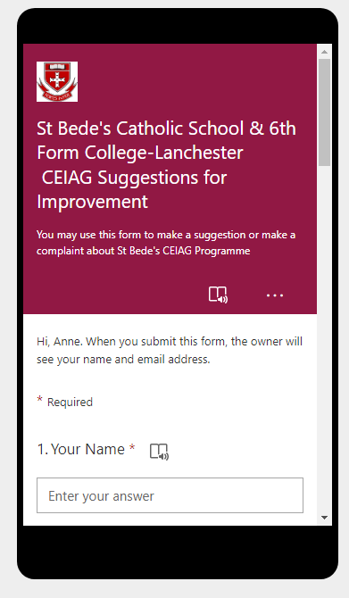
- If the complainant is not satisfied with the above decision, then it will be raised with the board of governors.
- The governors will examine the complaint and may wish to carry out further interviews or investigations They will respond within four weeks in writing. Their decision will be final.
Any complaints with regards to provider access can be raised following the school complaints procedure or directly with The Careers & Enterprise Company via provideraccess@careersandenterprise.co.uk

This form can be accessed via this link
https://forms.office.com/e/90e7vDwLKi

KEY STAFF
Headteacher: Mrs C Hammill
Link Governor: Mr D Dixon
SLT link:
Career Progression Manager: Mrs A Jukes
Ethos &Personal Development Coordinator: Mrs M Kelsey
Special Education Needs and Disability Coordinator: Mrs N McCarthy
Work Experience Coordinator: Mrs A Jukes

Review May
Further review Spring Term

